INSTITUT TEKNOLOGI BANDUNG
<NAMA UNIT KERJA>
Jalan ...............Bandung Kode Pos ......,Telp.: +6222 ........., Fax.: +6222 ......., e-mail: ........

SURAT EDARAN

NOMOR : .................................

TENTANG
........................................................................................

Yth.
- ..........................;
- ..........................;
- ..........................;
- ………………………..dst.

Dasar (pembuatan Surat Edaran) ..................

Isi Surat Edaran ..........................................

Penutup surat……………………………………………

tanggal ........................

JABATAN (KETUA/REKTOR/DLL....)

Tanda tangan

NAMA PEJABAT
NIP ..........................

Tembusan :
- ...................;
- ...................;
- …………………dst.

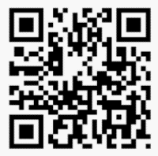
Contoh penempatan QR Code di dalam Naskah Dinas korespondensi ITB

